GOOGLE SITES ANALYSIS USING GOOGLE ANALYTICS

ASSIGNMENT-4

|  |  |
| --- | --- |
| NAME: | ARYAN GUPTA |
| SAP ID: | 500094848 |
| COURSE: | BBA(ABD) |
| SEMESTER: | 4TH |

INTRODUCTION

Google sites have created of BMW M.

Screen shots have been provided of both google analytics and Google sites

Below refers to the page no. of the Report

PAGE 2: GOOGLE SITES AND SCREENSHOTS OF GOOGLE SITES

PAGE 6: GOOGLE ANALYTICS AND SCREENSHOTS OF GOOGLE ANALYTICS

GOOGLE SITE LINK:

https://sites.google.com/view/bmw-aryan-gupta/home

[GOOGLE SITES ARYAN BMW](https://sites.google.com/view/bmw-aryan-gupta/home)

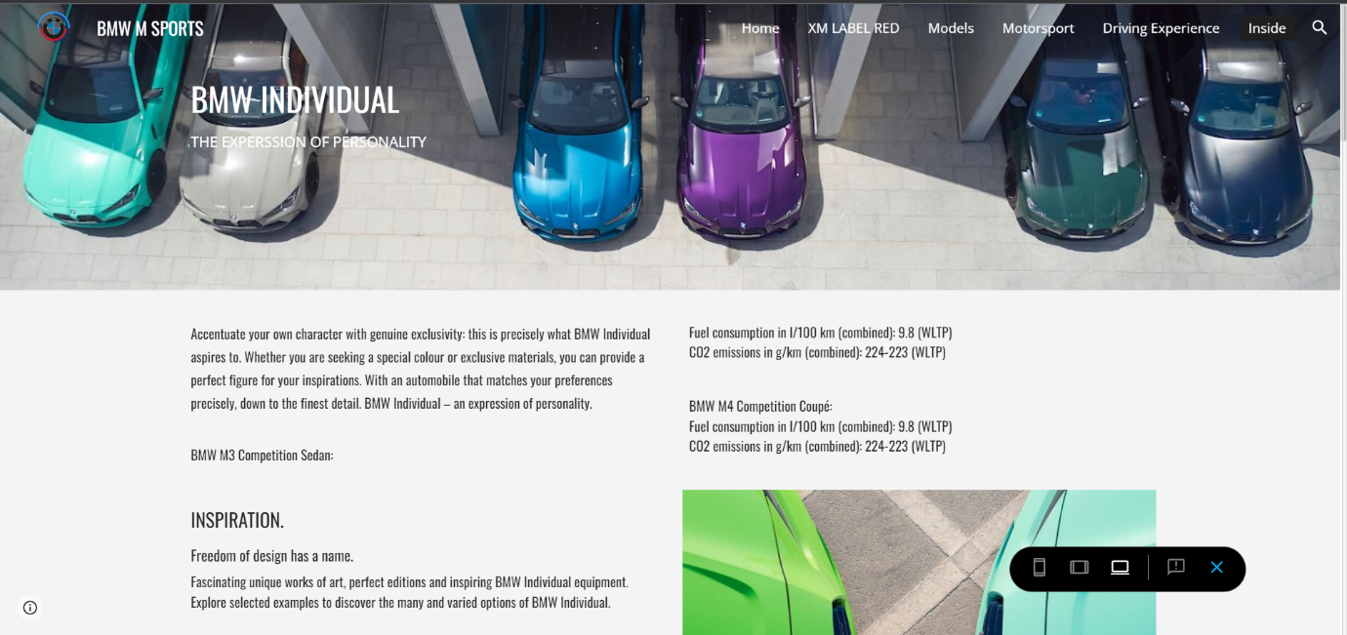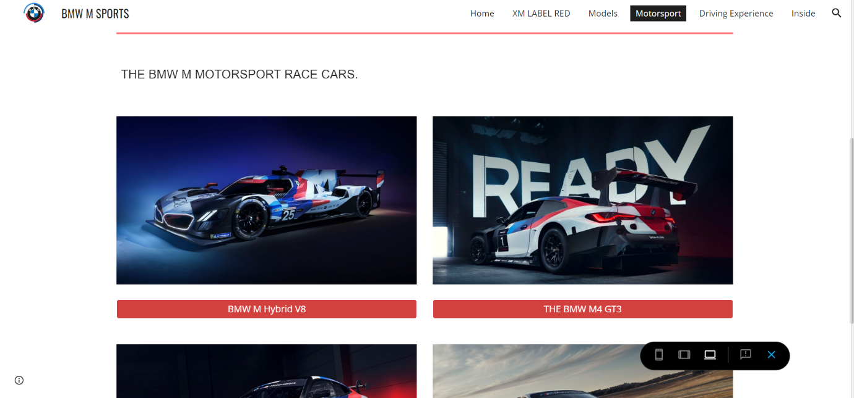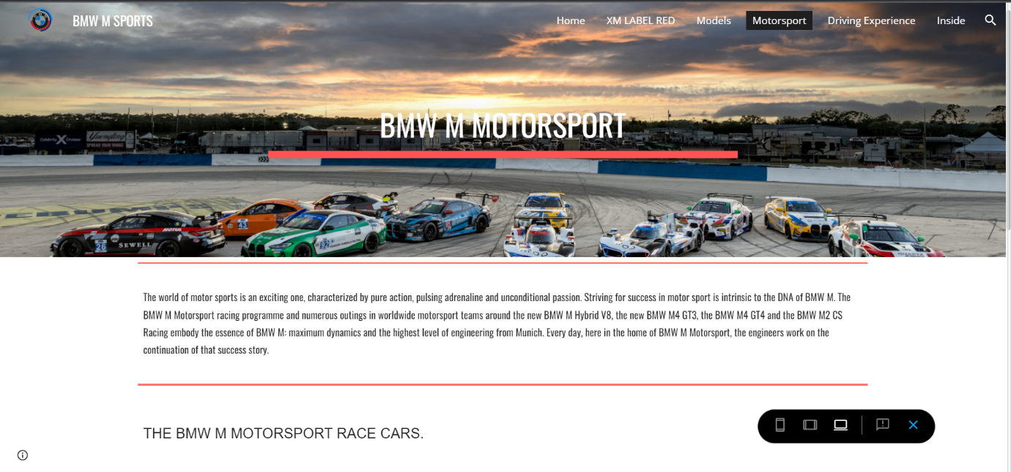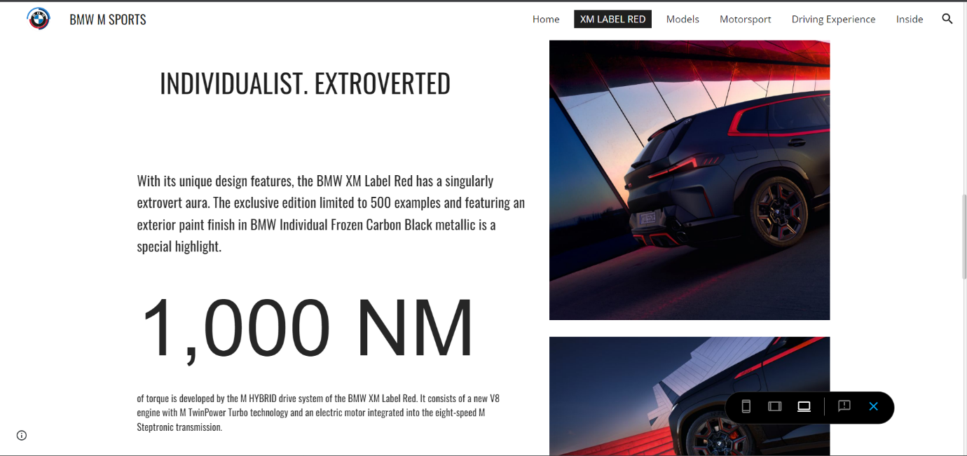

GOOGLE ANALYTICS

Google Analytics allows website owner to track, analyse & to keep the record various aspects of website traffic and user behaviour. Google Analytics is a web analytics service offered by Google. With google Analytics, website owners can monitor their website's performance, such as the number of visitors, pageviews, bounce rates, session duration, and conversion rates, among other metrics.

So, in this picture 1we can see the home page of the property we have created for our site & the graph that shows the no of users that visited our site in last one week. We can change it to month or year also. In second chart at the right, we can see the users in last 30 Min that visited our site. In Picture two We can also see the country or city from where the user has visited our site. This will help us to target that particular area.

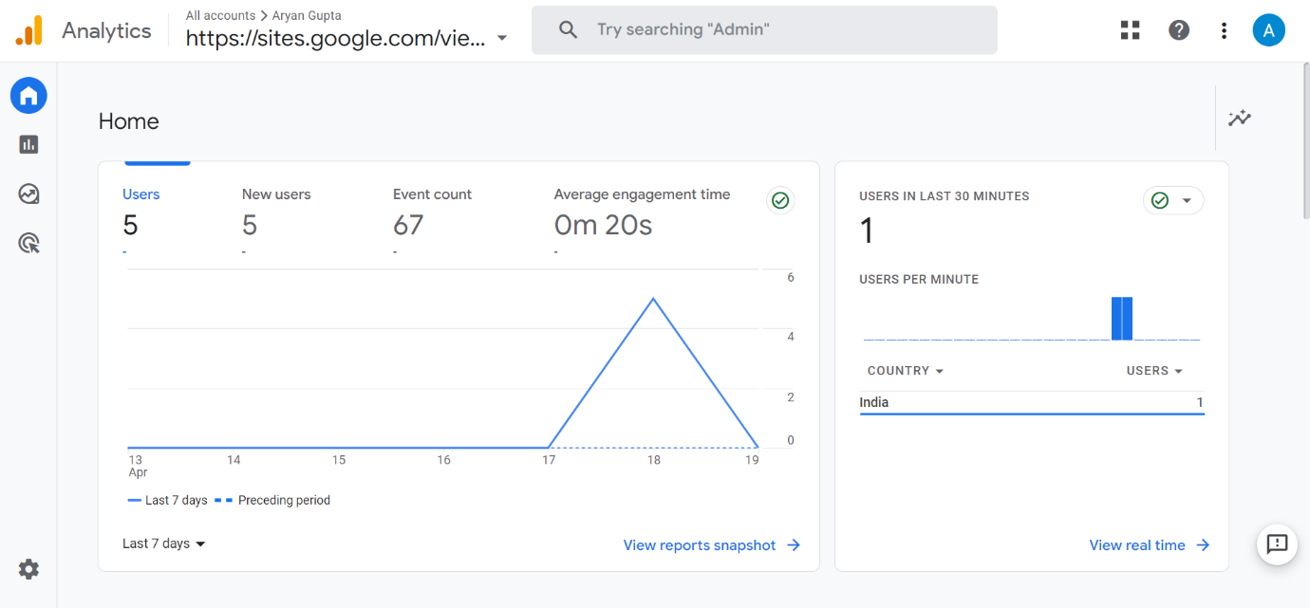

Picture-1

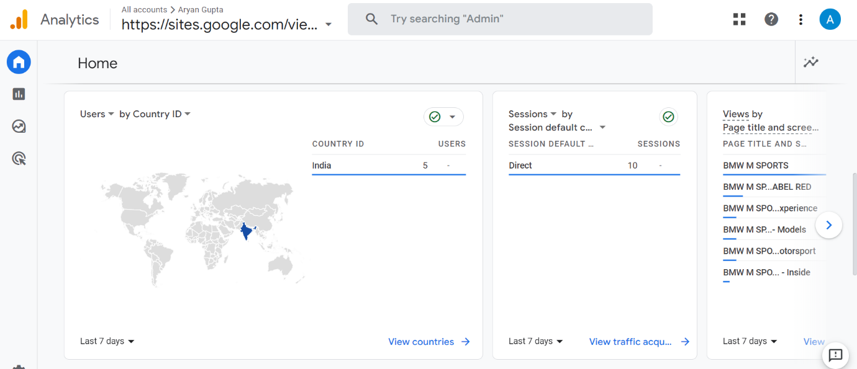

PICTURE-2

Now we come to REPORT section of Google Analytics in this we will get the detailed insight about the

In the 3rd Picture we can see the Acquisition. Acquisition refers to the process of acquiring users to your website and the channels that bring them there. Acquisition metrics provide insight into how visitors found your website and how they interact with it. 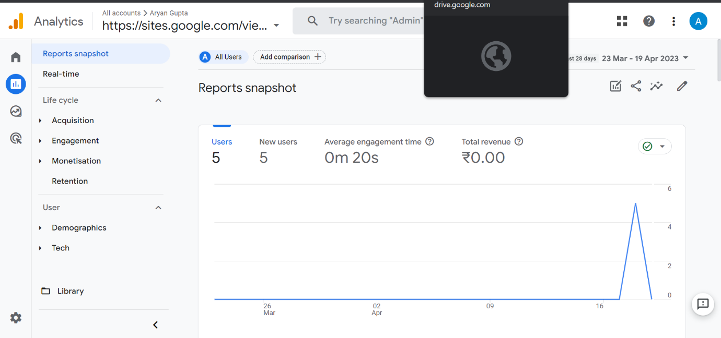

PICTURE-3

In this user acquisition we can see “New users by first default channel group over time” and “New users by First default channel group”

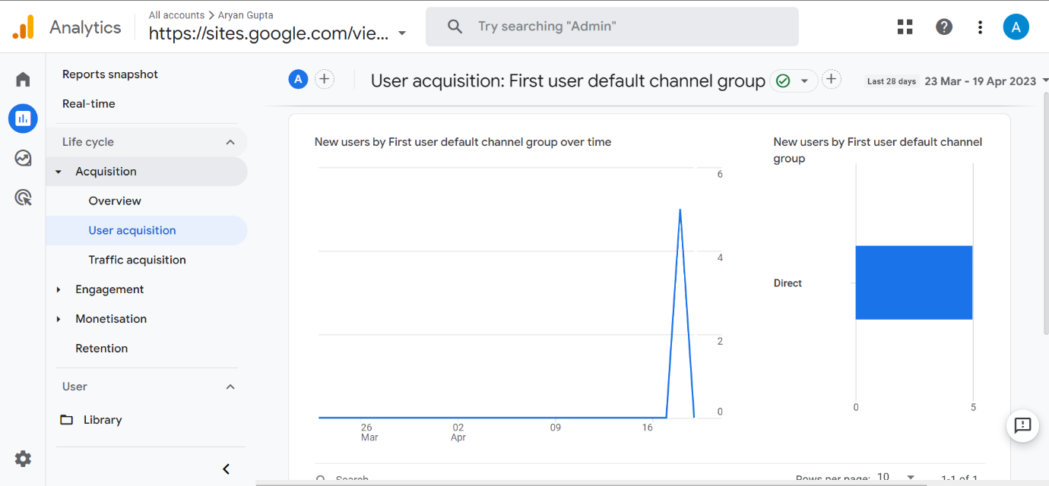

PICTURE-4

Traffic Acquisition refers to the process of acquiring website visitors through various channels such as organic search, paid search, social media, referrals, email marketing, and direct traffic.

In this Traffic Acquisition we can see “Users by session default channel group over time” and “Users by session default channel group”

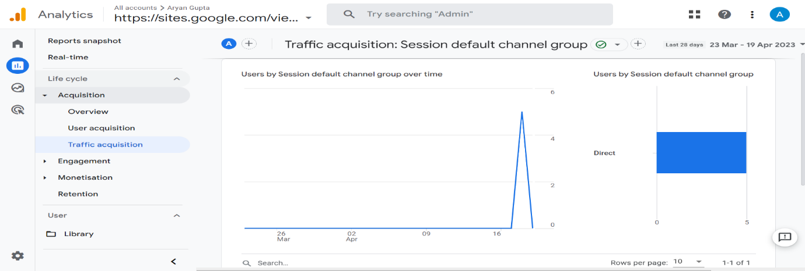

Engagement in Google Analytics refers to how users interact with your website or app, such as how long they stay on your site, how many pages they view, and how frequently they visit.

In this we can see Event count by event name and views by page title and screen class

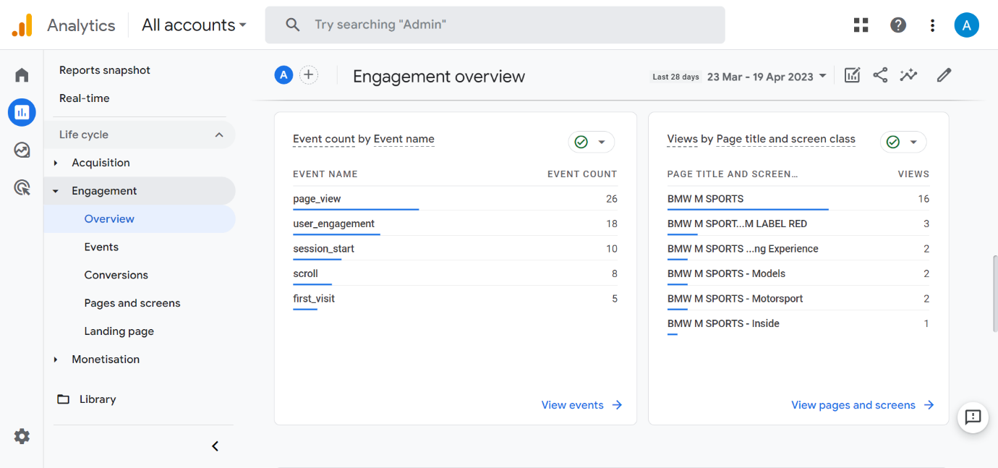

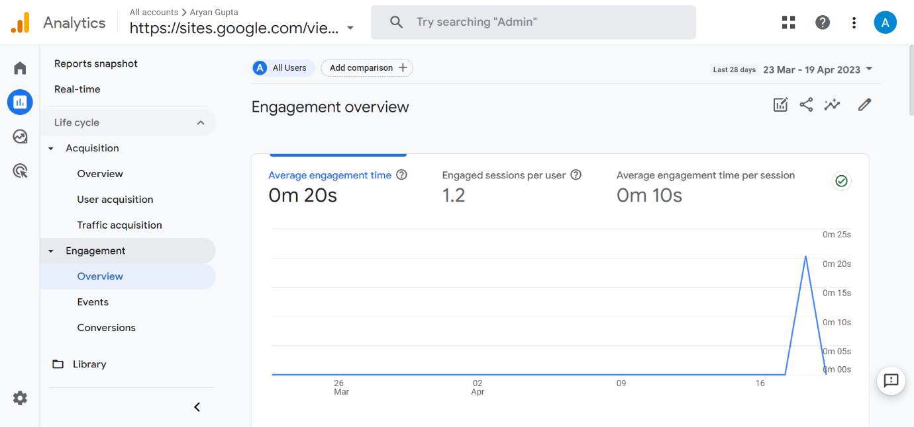

Engagement events in Google Analytics refer to user interactions on a website or app that are tracked by the use of event tracking codes. These interactions can include actions such as clicking on a button, filling out a form, watching a video, or scrolling through a page

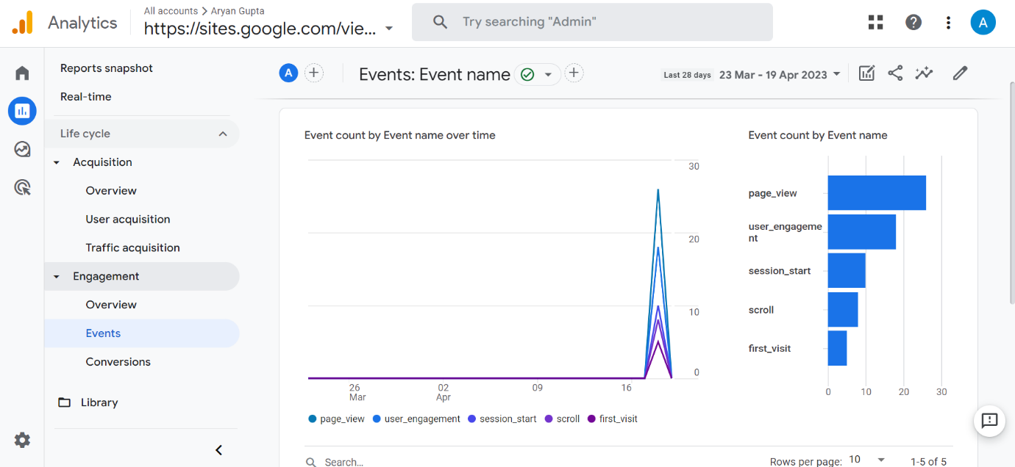

There is one more feature that is monetisation that show the record that any purchases have been done through site or any publisher add revenue has been generated etc.